Group members

Siddhi Dave (0951386) Sec - 31

Nidhi Jariwala (0953841) Sec - 31

Aditya Bhojani (0957691) Sec – 31

Date of submission: 31st Jan 2021

|  |  |
| --- | --- |
| Close-up image showing the leaf-sides of two oversized books side-by-side on a bookshelf, with additional books in soft focus background  Institute Finder  Group 6 |  |

# **Team Charter**

## **Team Name**

*Institute Finder Group*

## **Team Members**

*Siddhi Dave, Phone: 437-2443672, email:* [*s_dave108222@fanshaweonline.ca*](mailto:s_dave108222@fanshaweonline.ca)

*Nidhi Jariwala, Phone: 226-9277315, email:* [*n_jariwala @fanshaweonline.ca*](mailto:teja.nrs@gmail.com)

*Aditya Bhojani, Phone: 226-9982134, email:* [*a_bhojani@fanshaweonline.ca*](mailto:a_bhojani@fanshaweonline.ca)

## **Member Roles**

|  |  |
| --- | --- |
| **Project Management** | |
| *Team Leadership* | *Siddhi Dave* |
| *Project Planning* | *Nidhi Jariwala, Siddhi Dave* |
| *Project Documentation* | *Aditya Bhojani* |
| *Project Development* | *Nidhi Jariwala, Siddhi Dave* |
| *Project Testing and Maintenance* | *All* |
| **Analysis, Design and Documentation** | |
| *Diagramming and documenting requirements* | *Aditya Bhojani* |
| *Diagramming and documenting overall design* | *Aditya Bhojani* |
| *Technical documentation* | *Aditya Bhojani* |
| *Low level and High-Level Design* | *Nidhi Jariwala, Siddhi Dave* |
| **Web Application Development** | |
| **Presentation Layer Development** | |
| *Web Application User Interface Design* | *Siddhi Dave* |
| *Web pages style design* | *Siddhi Dave* |
| *Web programming* | *Siddhi Dave* |
| *Interactive testing* | *Aditya Bhojani* |
| **Business Layer Development** | |
| *Class design* | *Nidhi Jariwala* |
| *Business Logic* | *Nidhi Jariwala* |
| *Technical/lower level programming* | *Nidhi Jariwala* |
| *Unit and integration testing* | *Aditya Bhojani* |
| **Database Development** | |
| *Database design* | *All* |
| *SQL development* | *All* |
| **Web API Development** | |
| *Request and Response API* | *Nidhi Jariwala, Siddhi Dave* |
| *Data Processing* | *All* |
| *Data Insertion* | *All* |
| *Web API Testing* | *Aditya Bhojani* |
| **Other** | |
| *Report Development* | *Aditya Bhojani* |
| *Installer Development* | *Siddhi Dave, Nidhi Jariwala* |

## **Expectations**

1. *All the team members are responsible for all phase of Software Development*
2. *All the team members should be present in daily/weekly meetings*
3. *All the team members should keep track of the daily task and overall sprint user stories*
4. *All the team members should make commitments to ensure the success the capstone.*

## **Consequences**

*In the situation when team members can not complete the work withing the timeline then team members need to explain the reason and make up work they haven’t done. Same time if team member face difficulty to complete the task then other team members need to help.*

## **Agreement**

*Siddhi Dave, January 25, 2021*

*Nidhi Jariwala, January 25, 2021*

*Aditya Bhojani, January 25, 2021*

# **Project Vision**

## **Business Problem**

*Canadian education is considered among the top in the world. There are so many educational institutions in Canada which rank amongst the world best institutes. There are so many students from different part of the world which choose Canadian institutes for their higher studies every year.*

*Canadian institutes offer different courses in different streams like engineering, medical sciences, economics and many more. And several institutes also offer master on a particular field of study in each department. All the course offering of the institutes starts from diploma, degree, masters to PhD.*

*All these courses are of different tenure and they have specific admission requirements which students need to go through to get the admission in that course.*

*The student needs to go through each course and check their admission criteria and match them with his/her educational qualification. It is easily manageable when this whole process is to be done for a few courses but if it needs to be done for multiple courses (Ex:40 to 50 courses) it would take a lot of time.*

## **Product Overview**

*The product will be a website that the student can use to browse all the courses of college. The user could set the filter criteria according to their educational qualification. Upon applying the filter criteria, the system would compile a list of all the courses that the student qualifies to apply according to their educational qualification set in the filter criteria.*

*With the help of this website the user doesn’t have to go through all of the course checking the admission criteria manually. This would save user a lot of time while exploring courses.*

*The user can also save this search criteria in his account for future reference. The user can create and save as many search criteria as they want in their account. All the different searches that the user has made while setting filter criteria can also be modified from their account.*

## **Key Stakeholders**

|  |  |  |  |
| --- | --- | --- | --- |
| ***Stakeholder Role*** | ***Representative*** | ***Description*** | ***Responsibilities*** |
| ***Advisor*** | *Marc Beuno, Mona Abou Taka* | *Assign professional help to deliver the project.* | *To help team members achieve their goal in given timeline.* |
| ***Developer*** | *Siddhi, Nidhi* | *Create website framework, modules and oversee the integration of all modules.* | *Responsible for the system architecture and integration of different modules. Maintain GITHUB code and versioning of the product.* |
| ***Database Admin*** | *Siddhi, Aditya* | *Identify the database requirements for the system and create the database schema.* | *Create the database schema, database and link them to the system* |
| ***Quality Control*** | *Aditya, Siddhi, Nidhi* | *See that the system is bug free and maintenance of the system.* | *Do different testing like Black box testing & integration testing. Write test cases and test them.* |
| ***Document-***  ***ation*** | *Aditya, Nidhi* | *All the required knowledge of the system should be documented properly.* | *Make different documents like FSD (Functional Specification Document, BRD (Business Requirement Document) and diagrams.* |

## **Needs and Features**

|  |  |  |
| --- | --- | --- |
| ***Requirement ID*** | ***Need*** | ***Features*** |
| ***REQ01*** | ***WEB API Development*** | *There will be two APIs to get and set data to application database.*  *One API will get of college courses and other API will set the data to application database.* |
| ***REQ01.1*** | ***GET Data API*** | *This API will develop by college. College will develop API which send data to Institute Finder. If there is change in courses details, then this API will be responsible to send updated data to the Institute Finder.* |
| ***REQ01.2*** | ***SET Data API*** | *This API will get data from the first API and set data to the data to application database. The data will process and then store in application database.* |
| ***REQ02*** | ***Data Processing and Cleaning*** | *The data which get from API will process first. If there is any duplicate data, then remove the data-by-data processing and data cleaning. Then data will store in application database.* |
| ***REQ03*** | ***View courses*** | *The users can browse through a plethora of courses offered by colleges.*  *When user visit the application, they can see all the details of colleges and courses in tabular format.* |
| ***REQ03*** | ***Advance Search (Set Filter Criteria)*** | *The user is given with plenty of filter criteria which will narrow down his search results and will save user a lot of time.*  *The user can set the filter criteria like:*  *Course Type, City, Course department, Part Time/Full Time, DLI Registered Colleges and many more.* |
| ***REQ04*** | ***Data Save*** | *Using Data Save option, user can save data based on the filter user applied.*  *User can save data in CSV, Text format, PDF, Word Document.* |
| ***REQ05*** | ***Data Export/Download*** | *Using Data Export/ Download feature, user can download, and export data based on the filter they set.*  *This feature and Data Save is almost similar feature but only difference is this feature is also supporting the JPG and PNG format.* |
| ***REQ06*** | ***Data Print*** | *Using Data Print option, user can also print data based on the filter that user applied on data.*  *User has to connect the printer and after that they can print the data for future purpose.* |
| ***REQ07*** | ***CRUD Operation*** | *As per the REQ01.1, data will get from API, now in case of data change in the college data then it will reflect in application database by add, delete, update.* |

## **Project Plan**

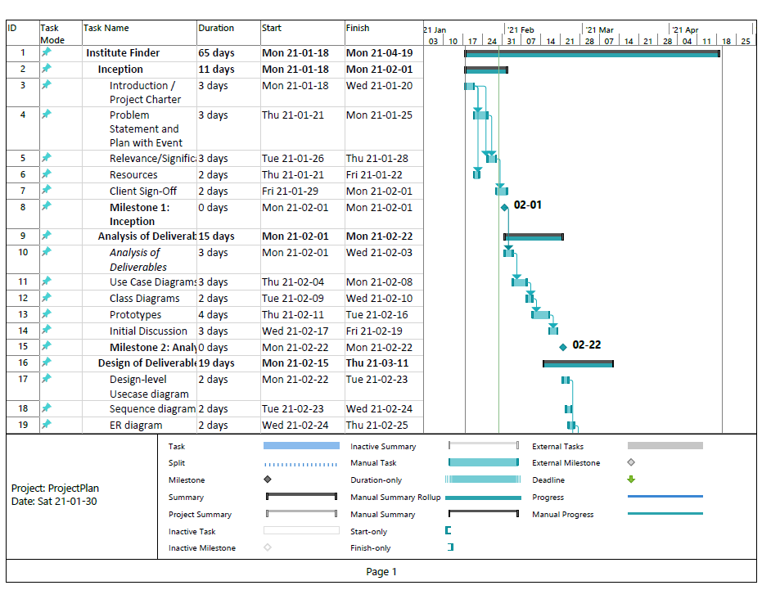

Figure 1.1 Project Plan

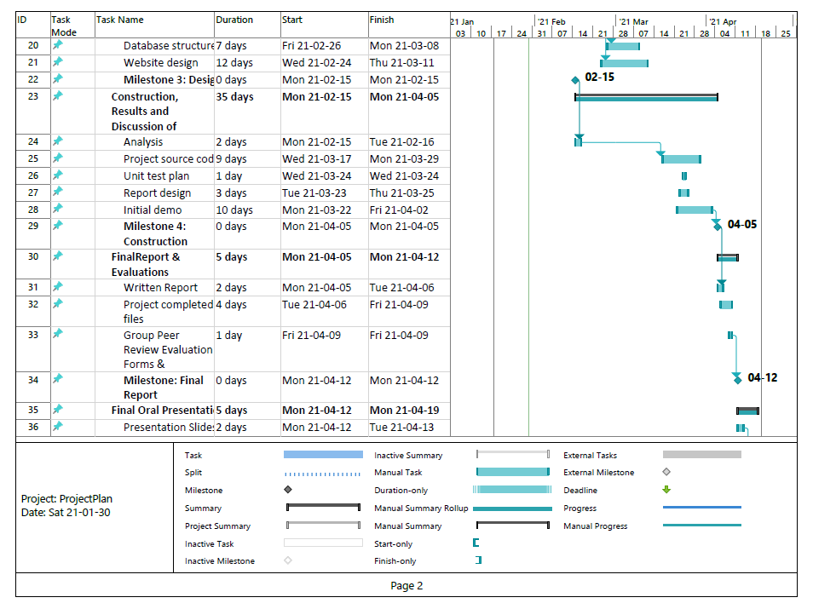

Figure 1.2 Project Plan

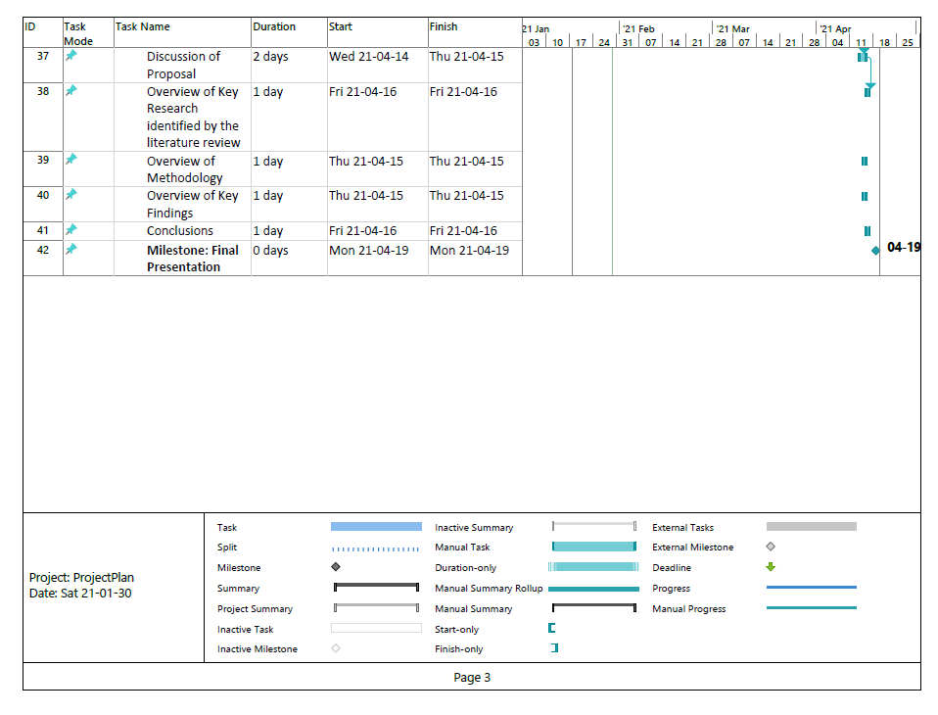

Figure 1.3 Project Plan